Password Reset

10.110.0.74

10.120.48.4 Adgo

10.110.0.69 NIIT ADVANT

These 2 are different directories .

Press Windows , Type user, now select the below app-

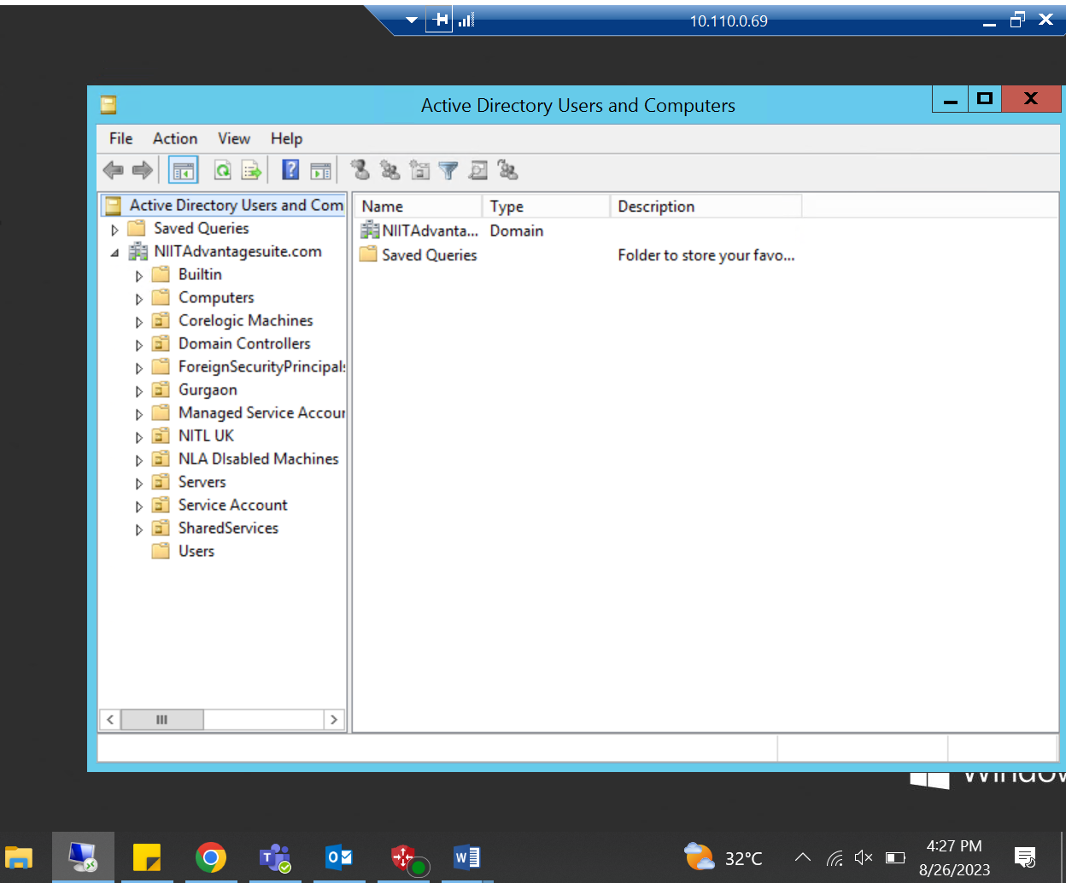

Now go to last option( Users ) .

Find the exact match of user name or the name provided by user.

Now right click on user and choose reset password and use and easy password. 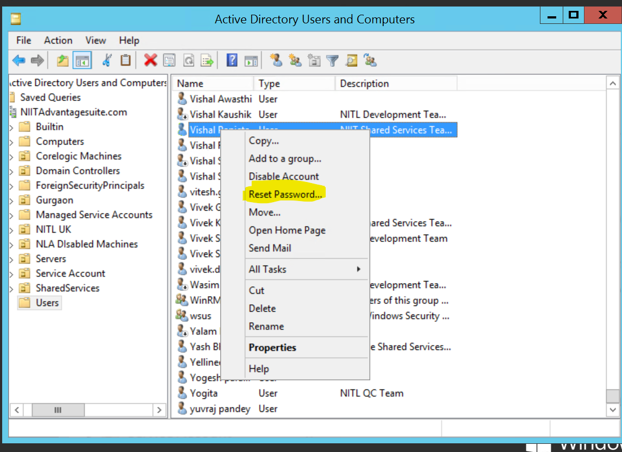

Now share the same password with user on a separate mail.

# Create new user-

To create new user, right click on user>new>user.

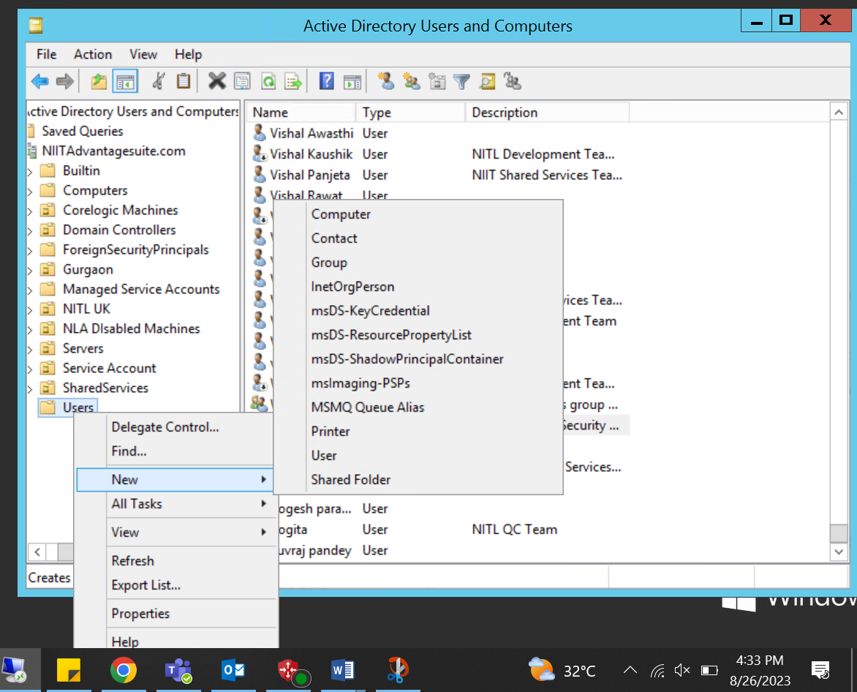

Now fill the details as asked-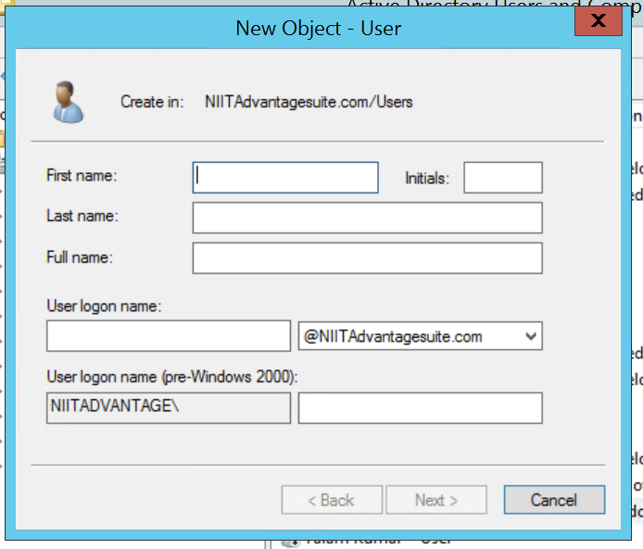

Now to grant different permissions to the user , the team will help you out.